Cloud Mask Replacement

Task

All Sentinel 2 L1C products are atmospherically corrected by ESA before distributing them as L2A products using the sen2cor algorithm. The process generates also a Scene Classification Layer (SCL) that is commonly used to identify pixels that are not usable for different reasons. More information is available at.<https://sentinels.copernicus.eu/web/sentinel/technical-guides/sentinel-2-msi/level-2a/algorithm> at the section Classification Mask Generation.

Tha SCL can contain 12 different values:

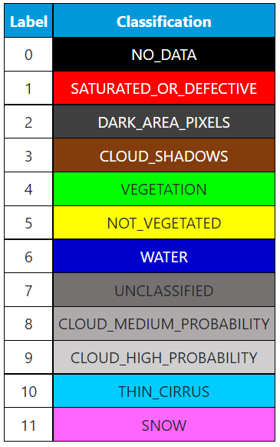

The task is to “extract” only pixels that have valid observation and set to 0 all other pixels. Please consider valid pixels those having the labels Vegetation, Not_vegetated, and Unclassified.

A small sample of Sentinel 2 product is available at the following link and it contains the products 12 reflective bands and the SCL mask.

[S2 Sample Ex](https://mallontechnology-my.sharepoint.com/:f:/p/christopher_collins/EtJNRrZ4jPtJhuvrql8VEfAB5-07AGDL8ZwhiVtN-94hYQ?e=C3xAvq)

Solution

Please provide your Python solution which will perform the above-described cloud mask procedure to an image. At a minimum, provide a method which has the following signature:

def apply_cloud_mask(image_filename, scl_mask_filename):

# Your code here

return masked_image_matrix

Your solution can be the necessary Python module(s) themselves, a Vagrant/Docker/Virtualenv solution, and anything else you feel necessary to complete and code the challenge. Please provide all files necessary to run your code, and a readme file with instructions.

Feel free to send a compressed archive (e.g. zip, tgz) of the code or a public link to the code (e.g. on GitHub, Gitlab, etc.)

Extras

As the domain we are in is image processing, a matrix by itself is not extremely useful. An optional extra credit is to write out the matrix into an image using GDAL, the Geospatial Data Abstraction Library. http://gdal.org

Your image should be a TIFF with LZW compression, with multiple bands, 8-bit unsigned int. (The masked image data should be scaled to 8-bit values before being written). The first band can simply have the masked image data. If you want, you can shift or modify the data so that it fits into RGB color space and write more than one band to visualize more than just a gray scale image.

If installation of GDAL is giving you problems try to write the image by other means/libraries opencv, rasterio, imageio (choose a different suitable image format)